نتایج برای داده اصلی :

20000 نمونه ی اول که به ده قسمت 2000 تایی تقسیم شده است و 13 ویژگی از بین 76 ویژگی انتخاب شده و نتایج برای رگرسور XGboost با PCA مقایسه شده اند.

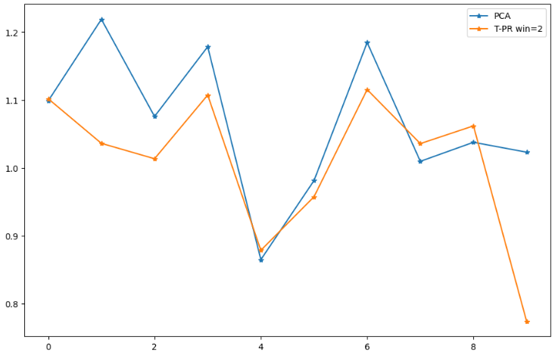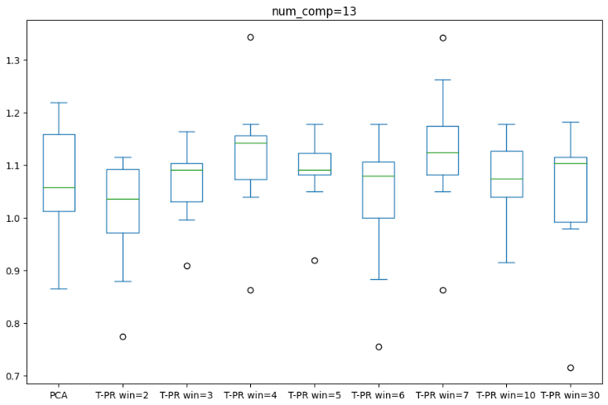

| **Dataset_index** | **PCA** | **T-PR win=2** | **T-PR win=3** | **T-PR win=4** | **T-PR win=5** | **T-PR win=6** | **T-PR win=7** | **T-PR win=10** | **T-PR win=30** |
| --- | --- | --- | --- | --- | --- | --- | --- | --- | --- |
| 0 | 1.098739 | 1.101834 | 1.091970 | 1.148099 | 1.148099 | 1.148099 | 1.262605 | 1.039697 | 1.091970 |
| 1 | 1.218800 | 1.036170 | 1.163373 | 1.178219 | 1.178219 | 1.178219 | 1.178219 | 1.178219 | 1.178219 |
| 2 | 1.075776 | 1.013521 | 1.093030 | 1.135388 | 1.093197 | 1.013521 | 1.080642 | 1.001367 | 1.115648 |
| 3 | 1.178402 | 1.107318 | 1.107318 | 1.343661 | 1.128197 | 1.106476 | 1.342369 | 1.128197 | 1.182165 |
| 4 | 0.864962 | 0.878691 | 0.908596 | 0.862627 | 0.919005 | 0.883559 | 0.862627 | 0.915016 | 0.979359 |
| 5 | 0.981365 | 0.957538 | 0.995253 | 1.067581 | 1.049455 | 0.995253 | 1.049455 | 1.038752 | 1.001733 |
| 6 | 1.184616 | 1.115353 | 1.081667 | 1.158753 | 1.080754 | 1.106491 | 1.157925 | 1.108741 | 1.115353 |
| 7 | 1.009686 | 1.035800 | 1.013555 | 1.039651 | 1.083432 | 1.083432 | 1.083432 | 1.039651 | 0.988406 |
| 8 | 1.037749 | 1.061883 | 1.136776 | 1.147871 | 1.108034 | 1.073743 | 1.159365 | 1.159365 | 1.114877 |
| 9 | 1.023158 | 0.774057 | 1.089321 | 1.089321 | 1.089321 | 0.755033 | 1.089321 | 1.122894 | 0.715225 |
| var | 0.011621 | 0.012077 | 0.005653 | 0.014780 | 0.004879 | 0.016747 | 0.016752 | 0.006536 | 0.019069 |
| mean | 1.067325 | **1.008217** | 1.068086 | 1.117117 | 1.087771 | 1.034383 | 1.126596 | 1.073190 | 1.048296 |
| min | 0.864962 | 0.774057 | 0.908596 | 0.862627 | 0.919005 | 0.755033 | 0.862627 | 0.915016 | **0.715225** |
| max | 1.218800 | **1.115353** | 1.163373 | 1.343661 | 1.178219 | 1.178219 | 1.342369 | 1.178219 | 1.182165 |

**20000 نمونه ی دوم** که به ده قسمت 2000 تایی تقسیم شده است و 13 ویژگی از بین 76 ویژگی انتخاب شده و نتایج برای رگرسور XGboost با PCA مقایسه شده اند.

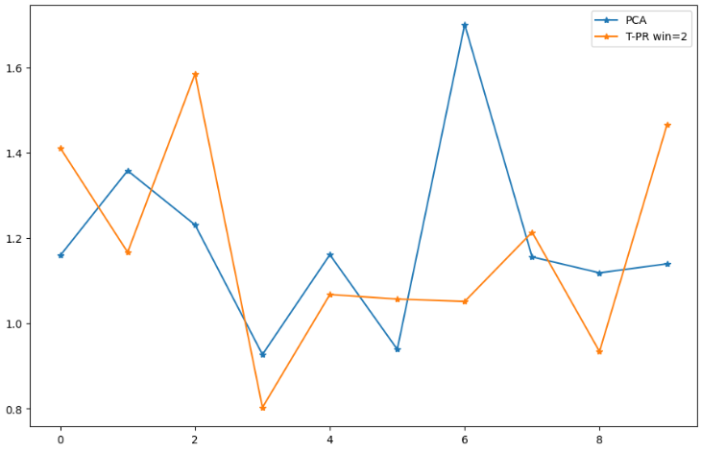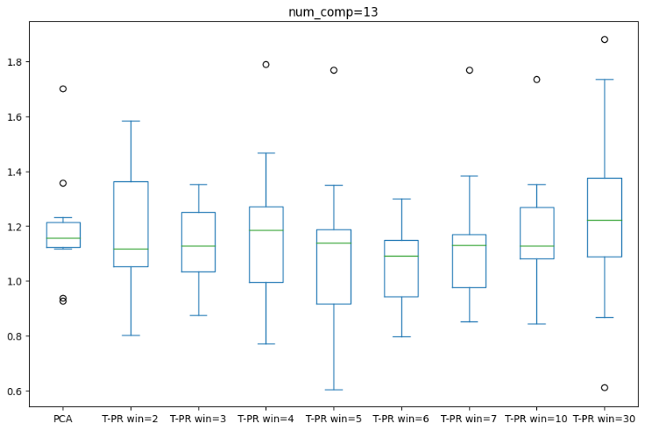

| **Dataset_index** | **PCA** | **T-PR win=2** | **T-PR win=3** | **T-PR win=4** | **T-PR win=5** | **T-PR win=6** | **T-PR win=7** | **T-PR win=10** | **T-PR win=30** |
| --- | --- | --- | --- | --- | --- | --- | --- | --- | --- |
| 0 | 1.158926 | 1.411492 | 1.251888 | 1.174231 | 1.174231 | 1.142965 | 1.174231 | 1.142821 | 1.174231 |
| 1 | 1.358057 | 1.166760 | 1.166760 | 1.166760 | 1.147348 | 1.147348 | 1.147348 | 1.076109 | 1.076109 |
| 2 | 1.230933 | 1.584903 | 1.348995 | 1.267985 | 1.348995 | 1.299922 | 1.382440 | 1.307784 | 1.327975 |
| 3 | 0.926975 | 0.802818 | 0.874435 | 0.770132 | 0.761428 | 0.797128 | 0.853104 | 0.844360 | 0.868506 |
| 4 | 1.160980 | 1.067619 | 1.245552 | 1.272960 | 1.087293 | 1.150933 | 1.153320 | 1.153320 | 1.269135 |
| 5 | 0.939033 | 1.056962 | 0.937383 | 0.936698 | 0.605087 | 0.936698 | 0.937383 | 1.053685 | 0.612709 |
| 6 | 1.700771 | 1.051391 | 1.065291 | 1.789844 | 1.768763 | 1.042059 | 1.768763 | 1.735613 | 1.735613 |
| 7 | 1.155771 | 1.213757 | 1.090948 | 1.195357 | 1.193307 | 1.195357 | 1.113430 | 1.113430 | 1.389973 |
| 8 | 1.118398 | 0.933863 | 1.352863 | 0.923854 | 0.859971 | 0.845170 | 0.905021 | 1.352863 | 1.881276 |
| 9 | 1.139609 | 1.465035 | 1.023448 | 1.465645 | 1.131084 | 0.962004 | 1.093093 | 1.099976 | 1.131084 |

|  | **PCA** | **T-PR win=2** | **T-PR win=3** | **T-PR win=4** | **T-PR win=5** | **T-PR win=6** | **T-PR win=7** | **T-PR win=10** | **T-PR win=30** |
| --- | --- | --- | --- | --- | --- | --- | --- | --- | --- |
| Var | 0.048179 | 0.060783 | 0.027371 | 0.084495 | 0.104823 | 0.026489 | 0.070596 | 0.056290 | 0.140228 |
| Mean | 1.188945 | 1.175460 | 1.135756 | 1.196347 | 1.107751 | **1.051958** | 1.152813 | 1.187996 | 1.246661 |
| Min | 0.926975 | 0.802818 | 0.874435 | 0.770132 | **0.605087** | 0.797128 | 0.853104 | 0.844360 | 0.612709 |
| Max | 1.700771 | 1.584903 | 1.352863 | 1.789844 | 1.768763 | **1.299922** | 1.768763 | 1.735613 | 1.881276 |

**20000 نمونه ی سوم**  که به ده قسمت 2000 تایی تقسیم شده است و 13 ویژگی از بین 76 ویژگی انتخاب شده و نتایج برای رگرسور XGboost با PCA مقایسه شده اند.

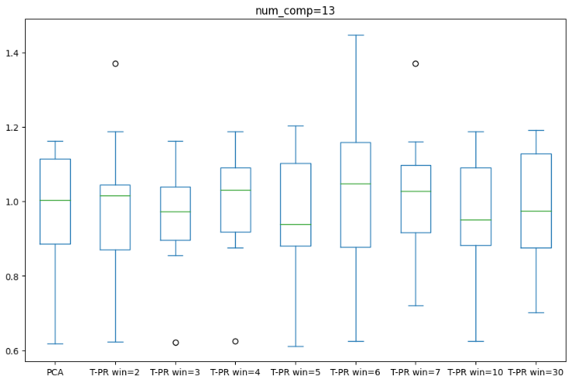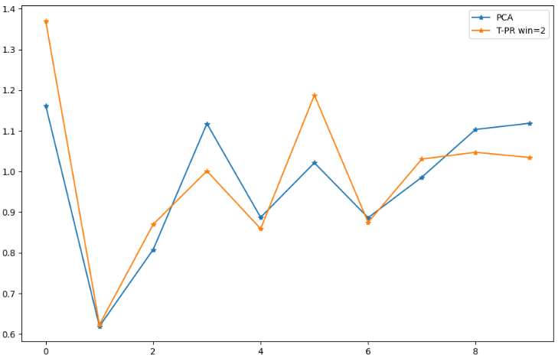

|  | **PCA** | **T-PR win=2** | **T-PR win=3** | **T-PR win=4** | **T-PR win=5** | **T-PR win=6** | **T-PR win=7** | **T-PR win=10** | **T-PR win=30** |
| --- | --- | --- | --- | --- | --- | --- | --- | --- | --- |
| 0 | 1.162036 | 1.370165 | 1.163071 | 1.122164 | 1.202757 | 1.370165 | 1.370165 | 1.163476 | 1.132463 |
| 1 | 0.619047 | 0.623174 | 0.621988 | 0.625289 | 0.611767 | 0.625289 | 0.720496 | 0.625289 | 0.701179 |
| 2 | 0.807841 | 0.869716 | 0.854973 | 1.063798 | 0.821744 | 0.821744 | 0.789569 | 0.803609 | 0.848442 |
| 3 | 1.117574 | 1.001062 | 1.043428 | 1.043428 | 0.971547 | 1.066923 | 1.016154 | 0.995682 | 1.043428 |
| 4 | 0.886966 | 0.858985 | 0.897893 | 0.888763 | 0.906265 | 0.883979 | 0.982544 | 0.879095 | 0.869405 |
| 5 | 1.021146 | 1.187439 | 1.025895 | 1.187439 | 1.187439 | 1.187439 | 1.064230 | 1.187439 | 1.191768 |
| 6 | 0.886094 | 0.874625 | 0.943211 | 0.876073 | 0.874625 | 0.876073 | 0.895657 | 0.905909 | 0.905909 |
| 7 | 0.985790 | 1.030382 | 1.001470 | 1.016940 | 1.016940 | 1.071303 | 1.109440 | 1.016940 | 1.149290 |
| 8 | 1.103266 | 1.047071 | 1.114073 | 1.099823 | 1.132211 | 1.030629 | 1.160875 | 1.114073 | 1.114073 |
| 9 | 1.118365 | 1.034346 | 0.894778 | 1.006580 | 0.896670 | 1.447475 | 1.037821 | 0.895629 | 0.893754 |

|  | **PCA** | **T-PR win=2** | **T-PR win=3** | **T-PR win=4** | **T-PR win=5** | **T-PR win=6** | **T-PR win=7** | **T-PR win=10** | **T-PR win=30** |
| --- | --- | --- | --- | --- | --- | --- | --- | --- | --- |
| Var | 0.029409 | 0.041110 | 0.023502 | 0.025996 | 0.033135 | 0.063264 | 0.034682 | 0.030164 | 0.026523 |
| Mean | 0.970813 | 0.989696 | 0.956078 | 0.993030 | 0.962197 | 1.038102 | 1.014695 | **0.958714** | 0.984971 |
| Min | 0.619047 | 0.623174 | 0.621988 | 0.625289 | **0.611767** | 0.625289 | 0.720496 | 0.625289 | 0.701179 |
| Max | **1.162036** | 1.370165 | 1.163071 | 1.187439 | 1.202757 | 1.447475 | 1.370165 | 1.187439 | 1.191768 |

**20000 نمونه ی چهارم**  که به ده قسمت 2000 تایی تقسیم شده است و 13 ویژگی از بین 76 ویژگی انتخاب شده و نتایج برای رگرسور XGboost با PCA مقایسه شده اند.

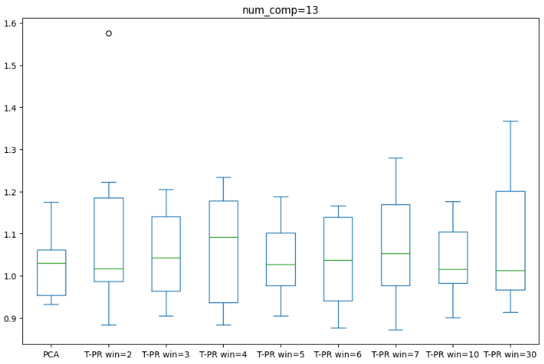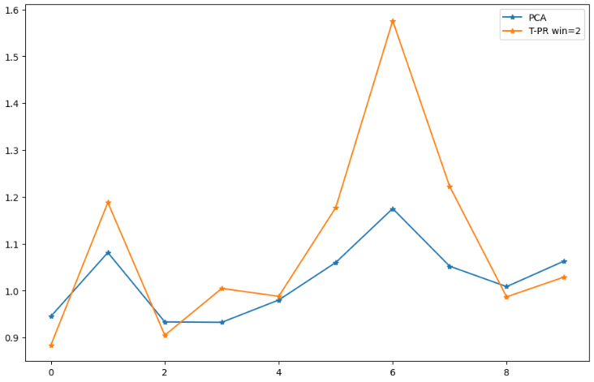

|  | **PCA** | **T-PR win=2** | **T-PR win=3** | **T-PR win=4** | **T-PR win=5** | **T-PR win=6** | **T-PR win=7** | **T-PR win=10** | **T-PR win=30** |
| --- | --- | --- | --- | --- | --- | --- | --- | --- | --- |
| 0 | 0.944998 | 0.883724 | 0.905914 | 0.883299 | 0.905914 | 0.925084 | 0.872645 | 0.900647 | 0.914642 |
| 1 | 1.081226 | 1.187968 | 1.160394 | 1.222104 | 1.026991 | 1.160394 | 1.049297 | 1.026991 | 1.239539 |
| 2 | 0.933178 | 0.904690 | 0.917923 | 0.904690 | 0.965082 | 0.876427 | 0.904690 | 0.904690 | 0.933634 |
| 3 | 0.932327 | 1.004645 | 0.955059 | 0.923355 | 0.974590 | 0.963075 | 0.979909 | 1.002314 | 0.989719 |
| 4 | 0.979963 | 0.987805 | 0.992533 | 0.976706 | 1.030300 | 0.934623 | 0.976706 | 0.976706 | 0.959663 |
| 5 | 1.059899 | 1.176908 | 1.205644 | 1.180217 | 1.176908 | 1.166331 | 1.280208 | 1.176908 | 1.205051 |
| 6 | 1.175009 | 1.575840 | 1.188487 | 1.173804 | 1.188487 | 1.166014 | 1.188487 | 1.174666 | 1.188487 |
| 7 | 1.052054 | 1.222277 | 1.081214 | 1.101374 | 1.125066 | 1.074518 | 1.112271 | 1.112271 | 1.368095 |
| 8 | 1.008457 | 0.986652 | 1.005452 | 1.233405 | 0.986652 | 1.005452 | 1.267594 | 1.005452 | 0.986652 |
| 9 | 1.062592 | 1.028520 | 1.082970 | 1.082970 | 1.028520 | 1.067887 | 1.056745 | 1.082970 | 1.037622 |

|  | **PCA** | **T-PR win=2** | **T-PR win=3** | **T-PR win=4** | **T-PR win=5** | **T-PR win=6** | **T-PR win=7** | **T-PR win=10** | **T-PR win=30** |
| --- | --- | --- | --- | --- | --- | --- | --- | --- | --- |
| Var | 0.006079 | 0.042158 | 0.012240 | 0.018475 | 0.008792 | 0.011791 | 0.020305 | 0.009815 | 0.024190 |
| Mean | 1.022970 | 1.095903 | 1.049559 | 1.068192 | 1.040851 | 1.033981 | 1.068855 | 1.036361 | 1.082311 |
| Min | 0.932327 | 0.883724 | 0.905914 | 0.883299 | 0.905914 | 0.876427 | 0.872645 | 0.900647 | 0.914642 |
| Max | 1.175009 | 1.575840 | 1.205644 | 1.233405 | 1.188487 | 1.166331 | 1.280208 | 1.176908 | 1.368095 |

**20000 نمونه ی پنجم**  که به ده قسمت 2000 تایی تقسیم شده است و 13 ویژگی از بین 76 ویژگی انتخاب شده و نتایج برای رگرسور XGboost با PCA مقایسه شده اند.

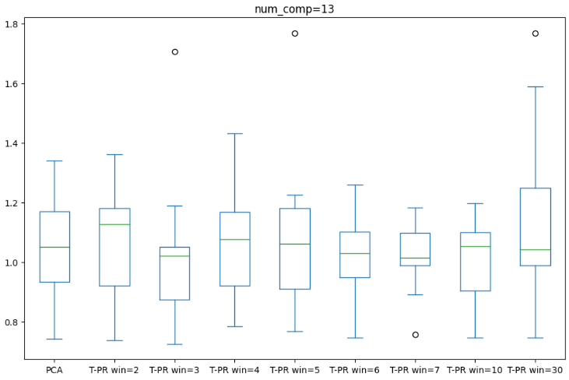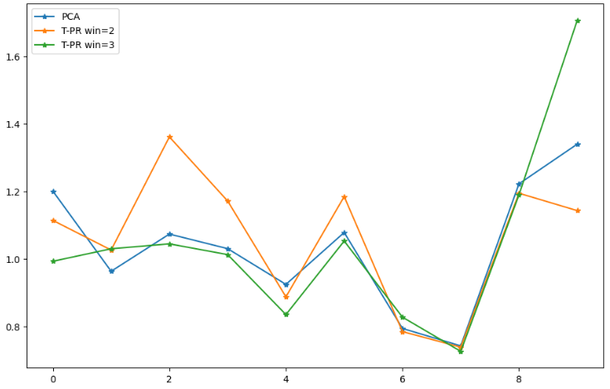

|  | **PCA** | **T-PR win=2** | **T-PR win=3** | **T-PR win=4** | **T-PR win=5** | **T-PR win=6** | **T-PR win=7** | **T-PR win=10** | **T-PR win=30** |
| --- | --- | --- | --- | --- | --- | --- | --- | --- | --- |
| 0 | 1.200249 | 1.113676 | 0.992701 | 1.256619 | 1.226207 | 1.098035 | 0.995029 | 1.113676 | 1.588672 |
| 1 | 0.963125 | 1.025935 | 1.029682 | 1.086289 | 1.029682 | 1.018130 | 1.015202 | 0.989903 | 1.031089 |
| 2 | 1.073210 | 1.360624 | 1.044179 | 1.065012 | 1.056346 | 1.041954 | 1.079295 | 1.065012 | 1.103798 |
| 3 | 1.030032 | 1.170912 | 1.012423 | 1.017596 | 1.065193 | 1.019515 | 1.012423 | 1.065193 | 0.975447 |
| 4 | 0.924322 | 0.887469 | 0.834948 | 0.887856 | 0.872186 | 0.925417 | 0.987508 | 0.875061 | 0.887469 |
| 5 | 1.077878 | 1.184102 | 1.052595 | 1.127824 | 1.180845 | 1.104289 | 1.104289 | 1.040994 | 1.052595 |
| 6 | 0.793934 | 0.784611 | 0.827414 | 0.785946 | 0.831836 | 0.809529 | 0.757843 | 0.831836 | 1.028172 |
| 7 | 0.742447 | 0.738570 | 0.726271 | 0.812749 | 0.769320 | 0.747911 | 0.891131 | 0.747911 | 0.747911 |
| 8 | 1.221852 | 1.193974 | 1.189095 | 1.181818 | 1.176751 | 1.181024 | 1.181818 | 1.196758 | 1.295696 |
| 9 | 1.339242 | 1.142537 | 1.705459 | 1.432416 | 1.767714 | 1.259914 | 1.136447 | 1.112749 | 1.767714 |

|  | **PCA** | **T-PR win=2** | **T-PR win=3** | **T-PR win=4** | **T-PR win=5** | **T-PR win=6** | **T-PR win=7** | **T-PR win=10** | **T-PR win=30** |
| --- | --- | --- | --- | --- | --- | --- | --- | --- | --- |
| Var | 0.035466 | 0.039534 | 0.072665 | 0.040543 | 0.079485 | 0.024938 | 0.015256 | 0.020210 | 0.099651 |
| Mean | 1.036629 | 1.060241 | 1.041477 | 1.065413 | 1.097608 | 1.020572 | 1.016098 | 1.003909 | 1.147856 |
| Min | 0.742447 | 0.738570 | 0.726271 | 0.785946 | 0.769320 | 0.747911 | 0.757843 | 0.747911 | 0.747911 |
| Max | 1.339242 | 1.360624 | 1.705459 | 1.432416 | 1.767714 | 1.259914 | 1.181818 | 1.196758 | 1.767714 |